**Practical 10**

**HTTPd, PHP**

1. HTTPd (DAEMON)
2. PHP

You may like to watch a video first: <https://www.youtube.com/watch?v=PzFO-73mAkg>

1. **Apache 2 web server**
2. Install the HTTP server the command

**Update your Ubuntu**

sudo apt-get update

**Install apache2**

sudo apt-get install apache2



1. Check if apache2 service is running

sudo systemctl status apache2

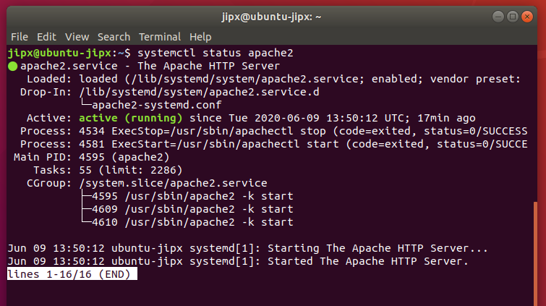

1. 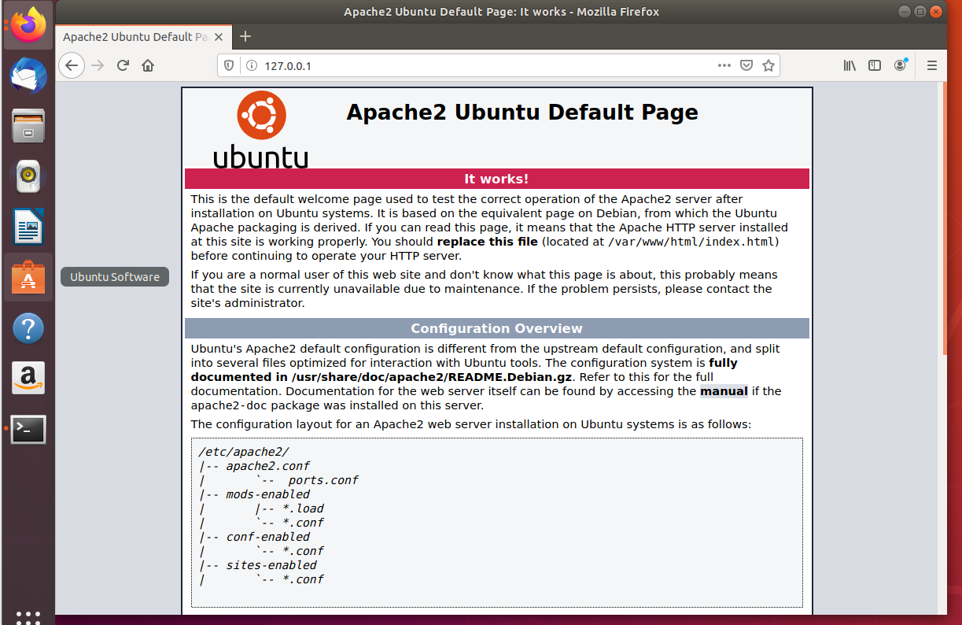Using your “Firefox” web browser to go to <http://127.0.0.1> to check out the pages.

For AWS ubuntu server:

If you encounter an error, such as connection refused, please refer to the **Troubleshooting** section (page 12).

1. You can find the IP address of your server by issuing

ifconfig –a

|  |  |
| --- | --- |
| IP address (of your server) | 192.168.73.128 |

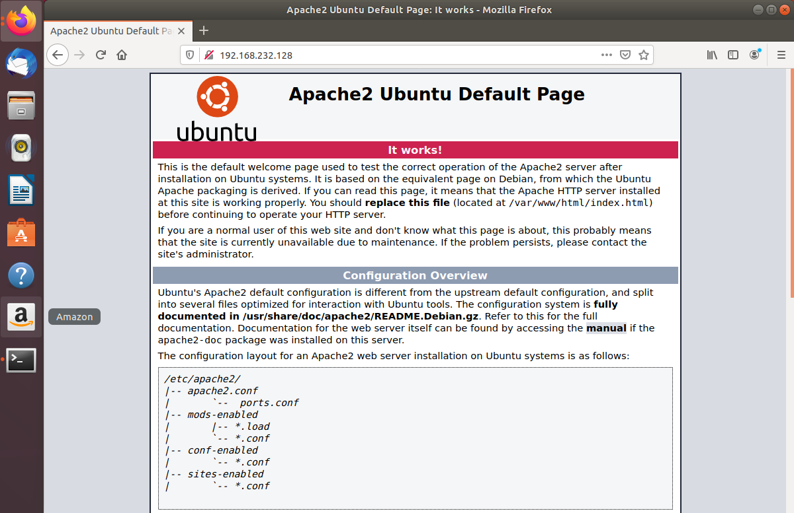Access your web site using the above IP address

1. Where is Apache HTTP server installed?

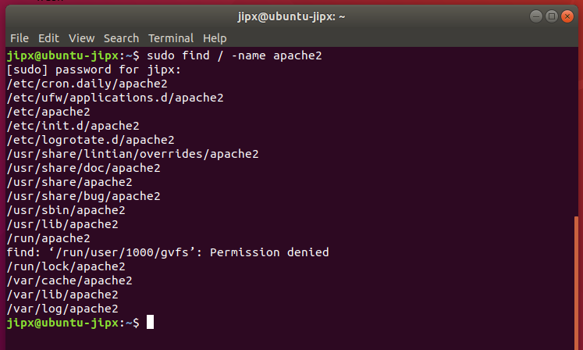Issue a “**find**” command to reveal all the Apache folders and files location.

1. Stop your apache2 service using

sudo service apache2 stop or

sudo /etc/init.d/apache2 stop



Check if apache2 service is stopped

sudo systemctl status apache2

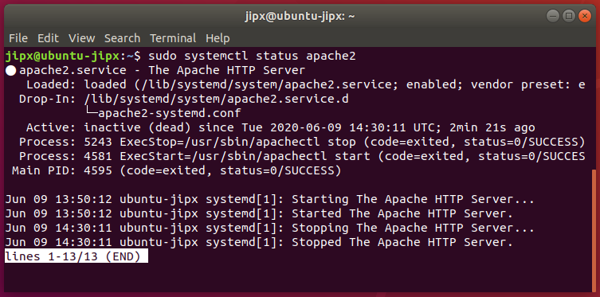

1. Using your “Firefox” web browser to go to <http://127.0.0.1> to check out the pages.

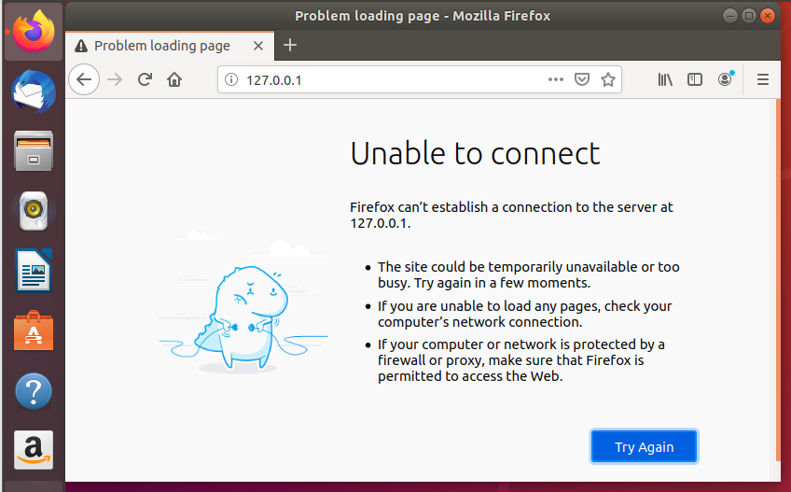

1. Restart the service using

sudo service apache2 restart or

sudo /etc/init.d/apache2 restart

1. **Create a web page**
2. Check your permission on /var/www folder

ls -ld /var/www

|  |  |  |  |
| --- | --- | --- | --- |
|  |  | binary | decimal |
| Owner: root | rwx | 111 | 7 |
| Group: root | r-x | 101 | 5 |
| other | r-x | 101 | 5 |

|  |
| --- |
| /var/www is the default root folder of your local web server, you host all your website files here and access it on the browser with url like [http://127.0.0.1](http://127.0.0.1/) or [http://localhost](http://localhost/)  You cannot simply copy paste stuff in this folder using your file browser. It is protected for security reasons, you will get a permission denied error message because by default you don't have write access permission here. |

1. Type sudo find / -name apache2.conf to locate the apache2.conf file

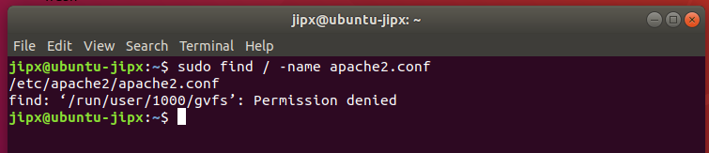

1. Type sudo cat /etc/apache2/apache2.conf to find out the folder/directory of Apache web server.
2. Type sudo cat /etc/apache2/envvars to find out the user and group the web server process is running under.

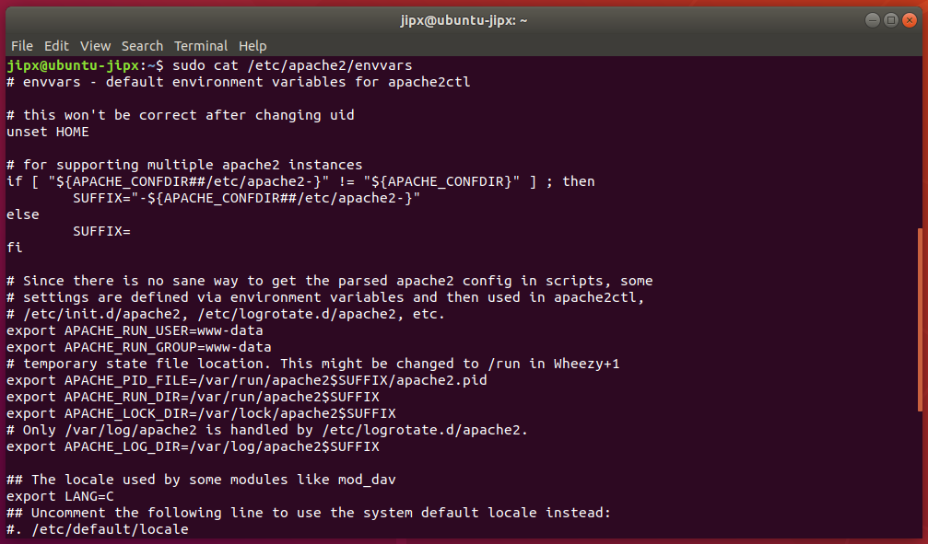

Record down the environment variable for APACHE_RUN_USER and APCHE_RUN_GROUP

|  |  |
| --- | --- |
| APACHE_RUN_USER | www-data |
| APCHE-RUN-GROUP | www-data |
|  |  |

1. Issue the following command

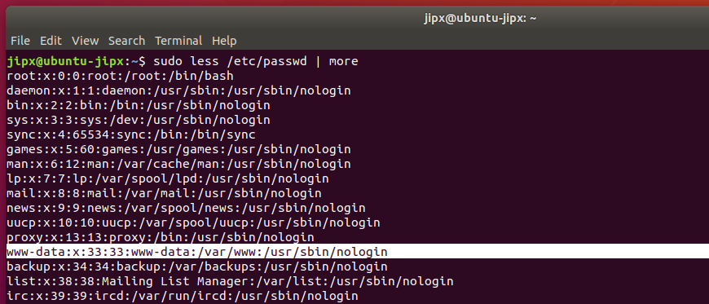sudo less /etc/passwd | more (more / etc/passwd)

1. Change the group for the folder

sudo chgrp -R www-data /var/www

|  |
| --- |
| The group ownership of a file or directory may be changed with chgrp.  In the command above, we changed the group ownership of /var/www from its previous group to "www-data". You must be the owner of the file or directory to perform a chgrp. |

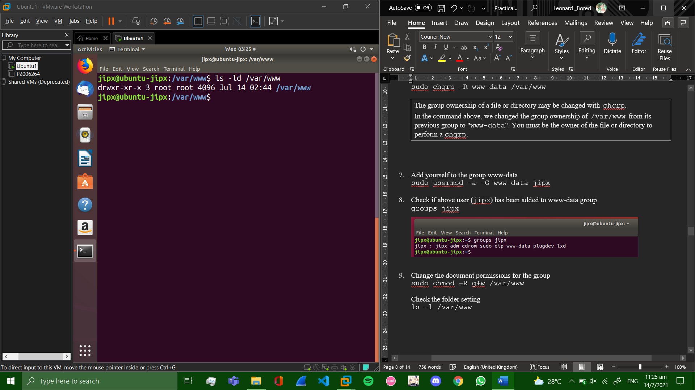

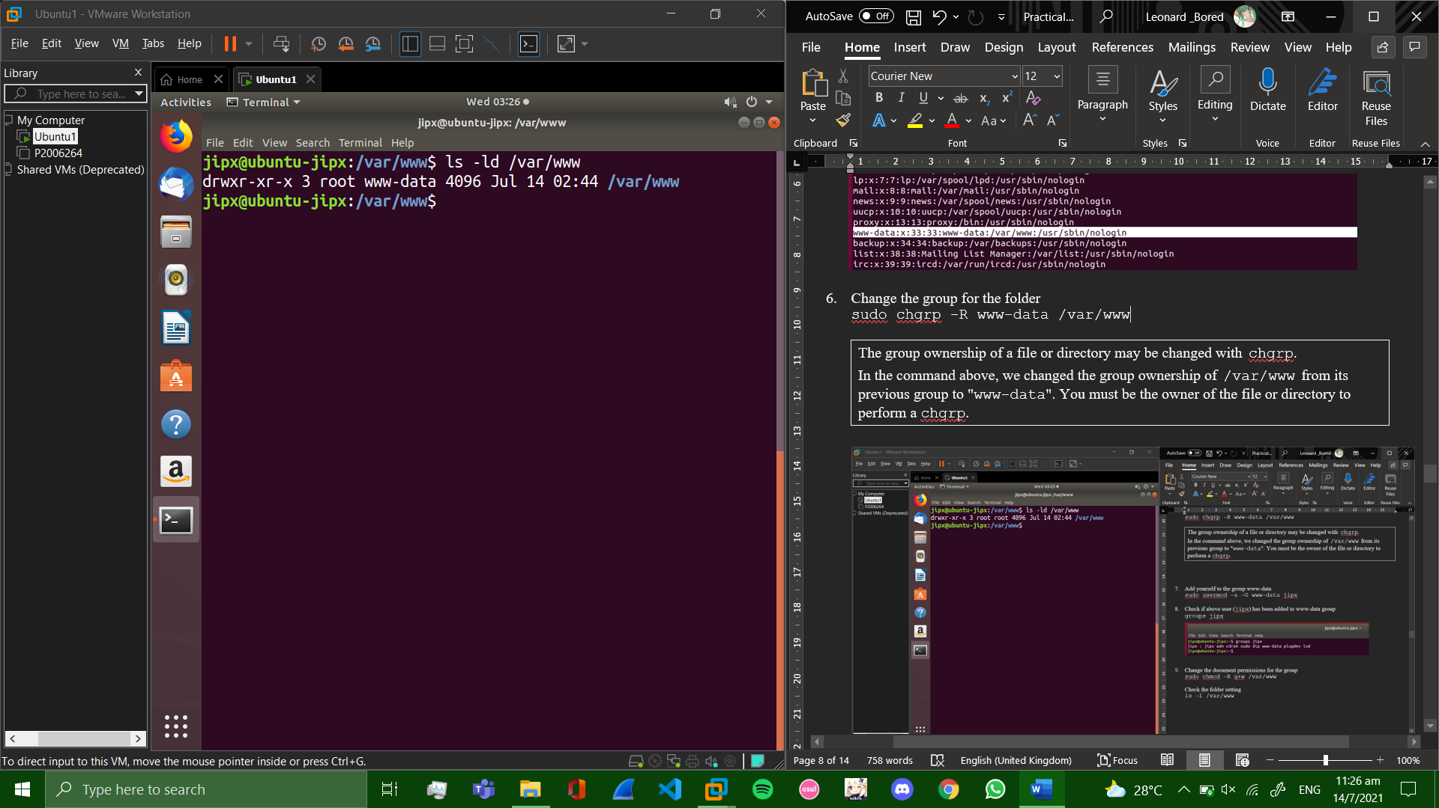

1. Add yourself to the group www-data

sudo usermod -a -G www-data jipx

(Have to reboot for new groups to be displayed)

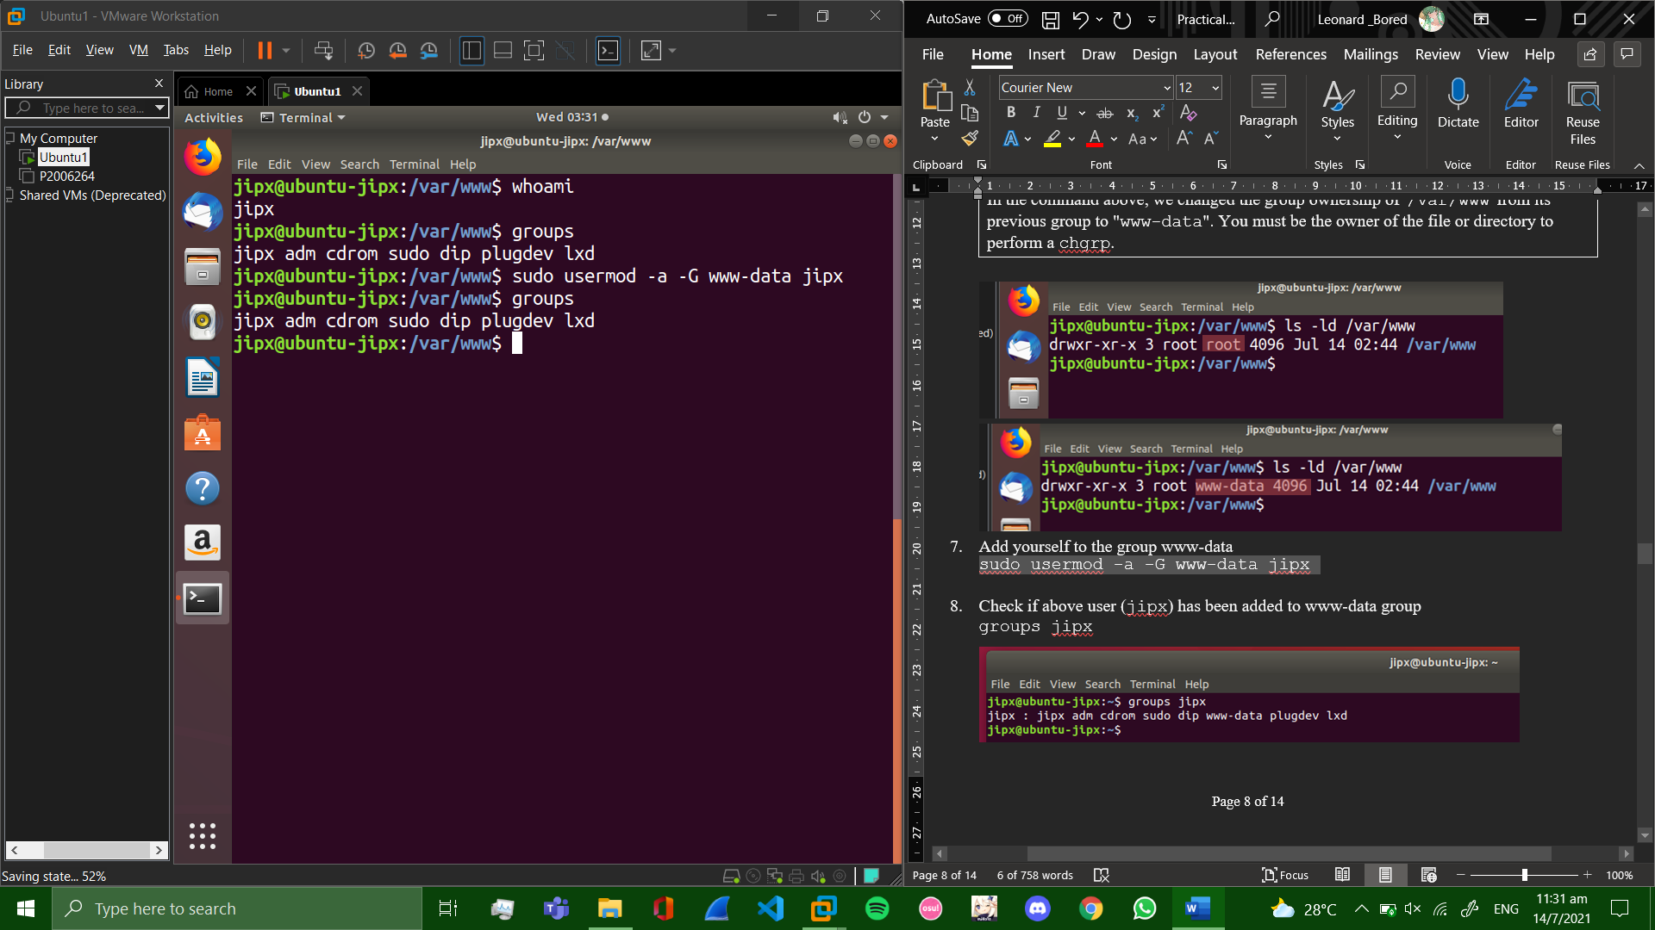

1. Check if above user (jipx) has been added to www-data group

groups jipx

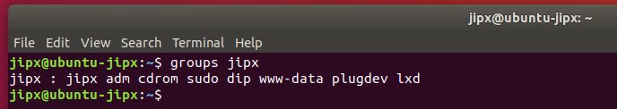

1. Change the document permissions for the group

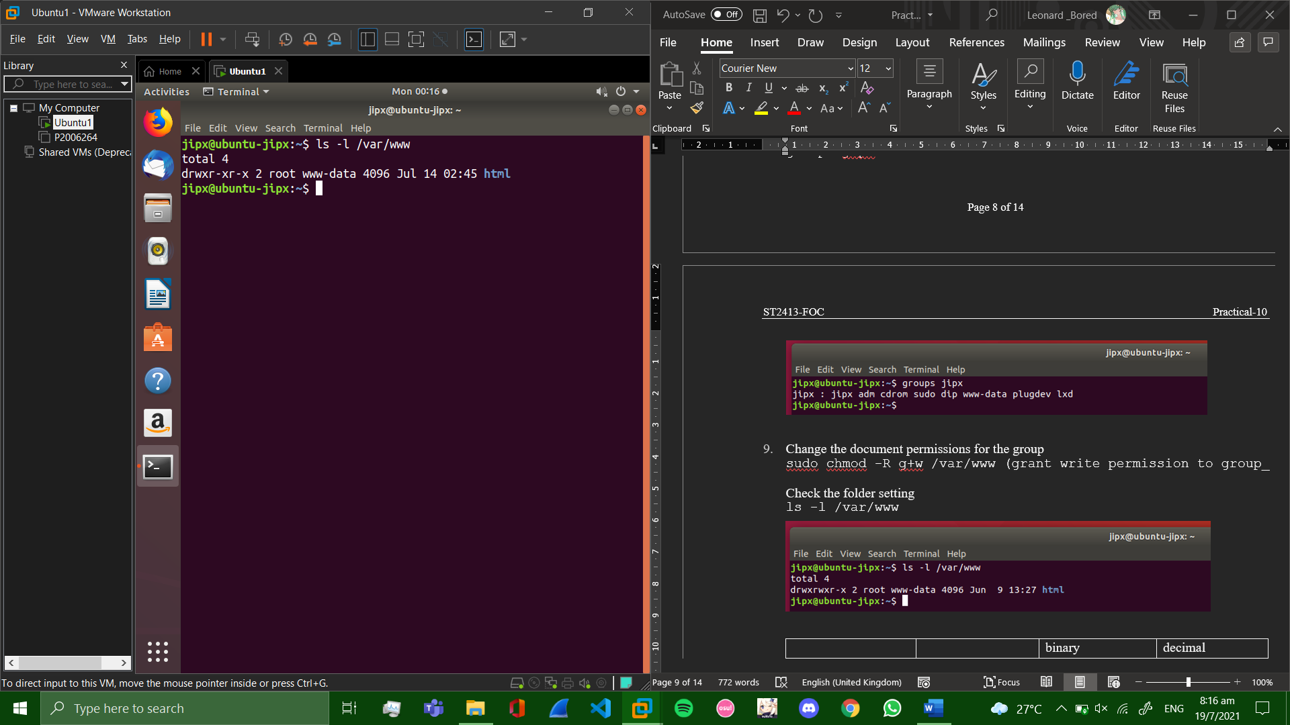

sudo chmod -R g+w /var/www (grant write permission to group)

Check the folder setting

ls -l /var/www

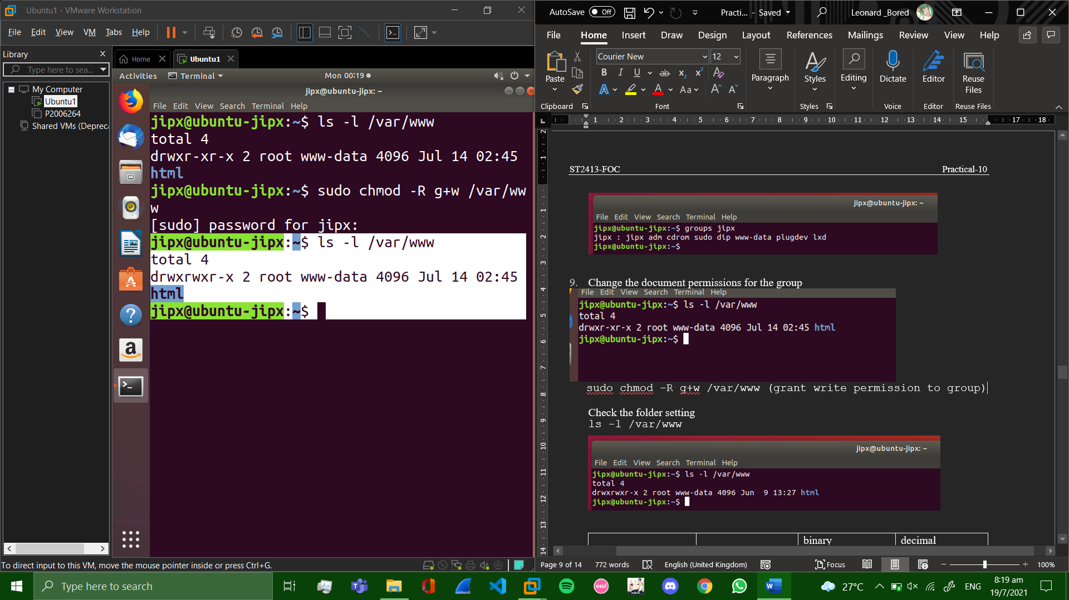

(given perimission to write to group /var/www)

|  |  |  |  |
| --- | --- | --- | --- |
|  |  | binary | decimal |
| Owner: root | rwx | 111 | 7 |
| Group: www-data | rwx | 111 | 7 |
| other | r-x | 101 | 5 |

sudo chmod -R g+w /var/www/html (redundant)

1. Create a file sudo vi /var/www/html/index1.htmlwith the following content (feel free to replace vi with nano)

<h1> Hello World </h1>

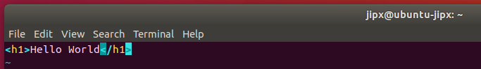

1. (Ctrl + 0 to save)
2. Ctrl + X to exit
3. Press enter
4. Using your “Firefox” web browser to go to <http://127.0.0.1/index1.html>

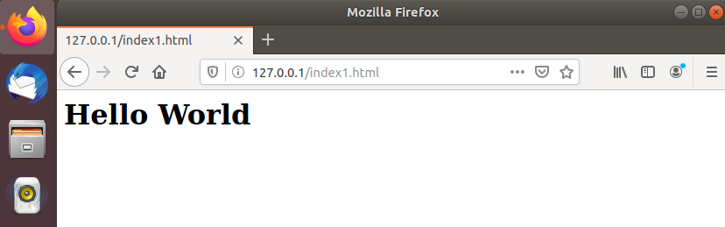

1. **Install PHP**

PHP 7.2 which is the default PHP version in Ubuntu 18.04 is fully supported and recommended for WordPress.

To [install PHP](https://linuxize.com/post/how-to-install-php-on-ubuntu-18-04/) and all required PHP extensions, run the following command:

sudo apt install php7.2 php7.2-cli php7.2-mysql php7.2-json php7.2-opcache php7.2-mbstring php7.2-xml php7.2-gd php7.2-curl

Restart apache2 so the newly installed PHP extensions are loaded:

sudo systemctl restart apache2

sudo vi /var/www/html/test.php (feel free to replace vi with nano)

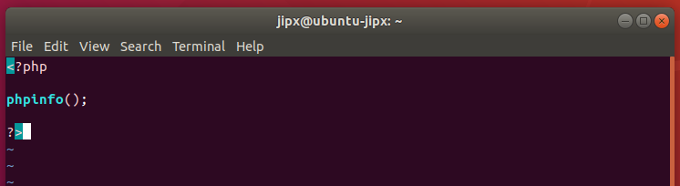

Now we can test whether our web server can correctly display content generated by a PHP script. To try this out, we just have to visit this page in our web browser. You'll need your server's public IP address again.

The address you want to visit will be:

http://your_server_IP_address/test.php or

http://localhost/test.php

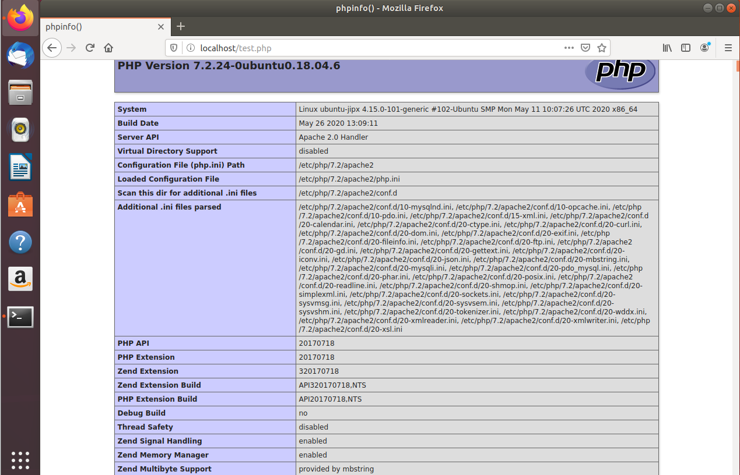The page that you come to should look something like this:

This page basically gives you information about your server from the perspective of PHP. It is useful for debugging and to ensure that your settings are being applied correctly. If this was successful, then your PHP is working as expected.

**You probably want to remove this file after this test because it could actually give information about your server to unauthorized users. To do this, you can type this:**

sudo rm /var/www/html/test.php

** You can always recreate this page if you need to access the information again later.

**Troubleshooting(for group tasks only)**

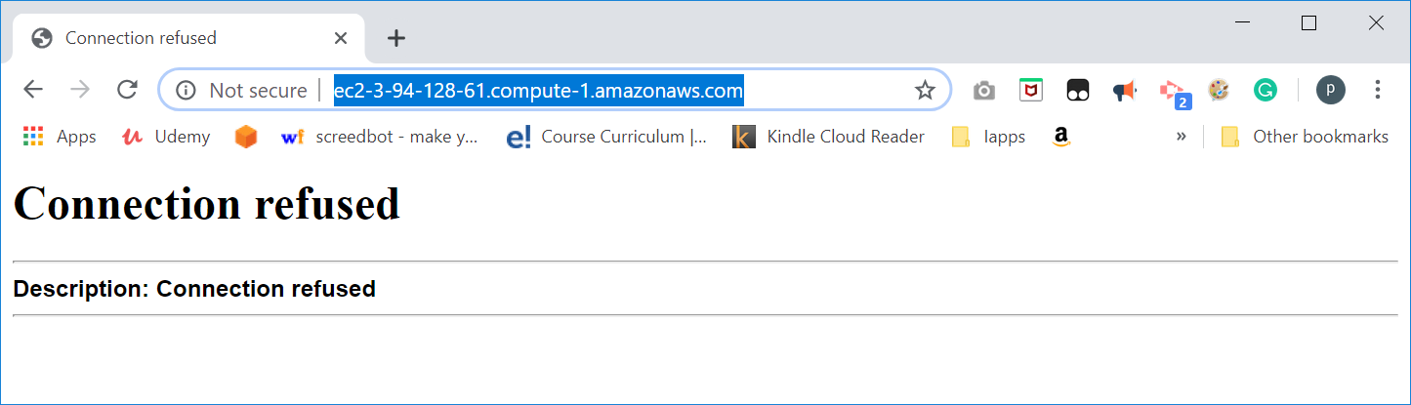

Go to AWS Console to Change the security group for the EC2 instance.  
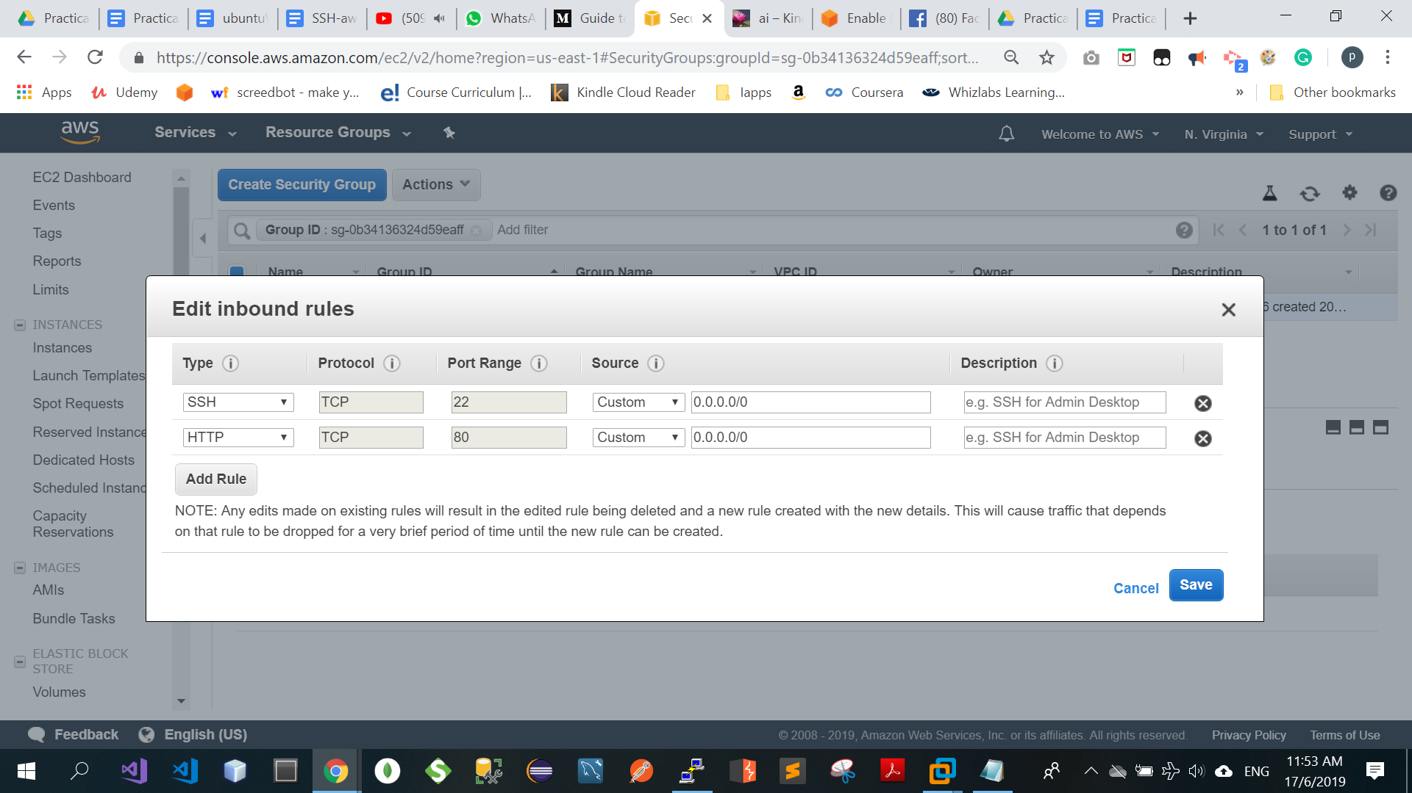  
  
After saving the security group, it will take effect immediately.

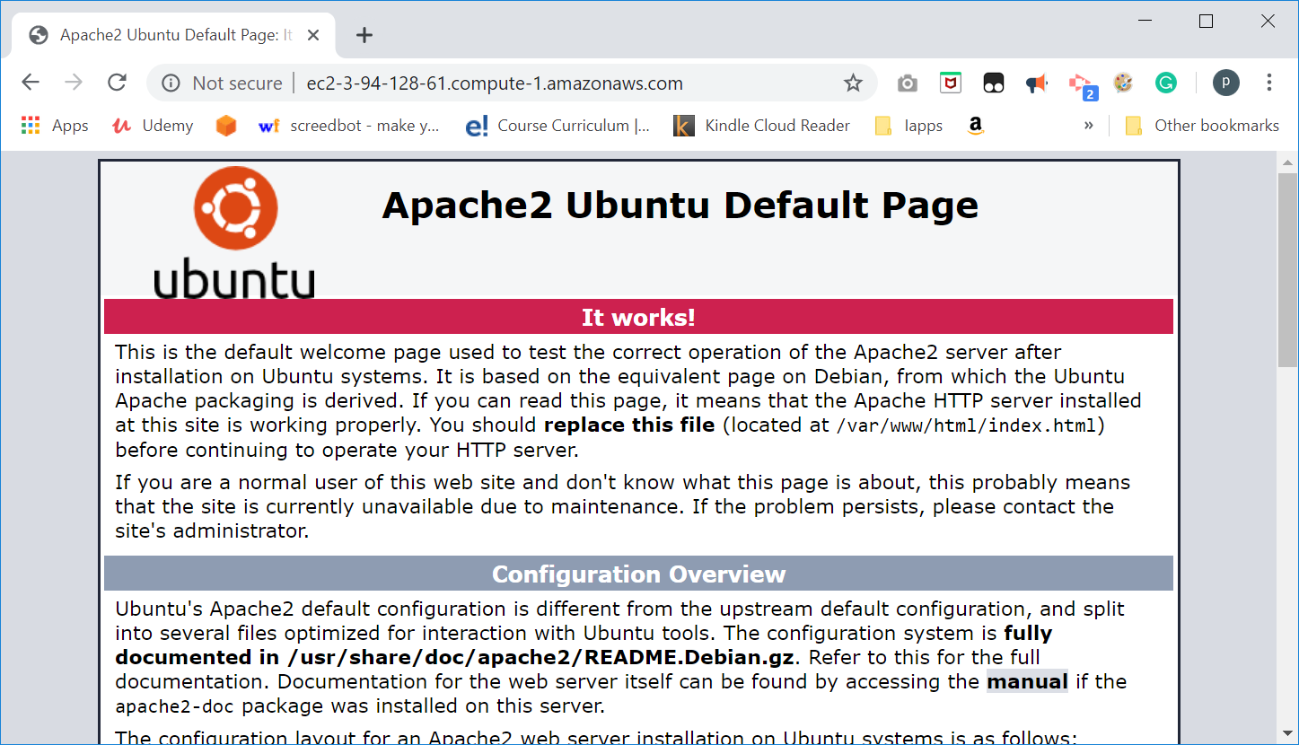

Reference: [How To Install Linux, Apache, MySQL, PHP (LAMP) stack on Ubuntu 16.04](https://www.digitalocean.com/community/tutorials/how-to-install-linux-apache-mysql-php-lamp-stack-on-ubuntu-16-04)

*End of Practical*

* 1. What have you learnt?

I have learned more about how to install stuff like php and apache 2 web server and get them both to function onto the linux ubuntu. I also learned how to properly test whether they are running by checking their status with the command *sudo systemctl status apache2 for apache and*  checking whether the installation of php was successful by going to the

[*http://localhost/test.php*](http://localhost/test.php) . Overall, this practical helped and guided me on what to do for my assignment in task 2.

2. Difficulties encountered and how you solved the problems?

When installation of both php and apache , there was a (lock) issue that popped out.

This made me unable to properly install it over to my linux , so I asked my teacher of a way to resolve this issue. Thankfully, I followed his instructions by either using sudo reboot command or manually rebooting the vm using the gui, I was able to properly install apache and php once the reboot was done.